Name: Vaishnavi Hemant Phalke Roll no: 47
Class: CSE(AI) SEDA PRN: 1252090032
Assignment 2

Title
- Compute and display summary statistics for each feature available in the dataset. (e.g. minimum value, maximum value, mean,
- range, standard deviation, variance and percentiles
- Illustrate the feature distributions using histogram.
- Data cleaning, Data integration, Data transformation, Data model building (e.g. Classication)

Import Required Libraries
import pandas as pd import numpy as np
import matplotlib.pyplot as plt import seaborn as sns

Load the dataset

0 | 1 | 0 | 3 | Braund, Mr. Owen  Harris | male | 22.0 | 1 | 0
1 | 2 | 1 | 1 | Cumings, Mrs. John Bradley (Florence | female | 38.0 | 1 | 0
 |  |  |  | Briggs Th...
2 | 3 | 1 | 3 | Heikkinen, Miss. Laina | female | 26.0 | 0 | 0

Check Shape of Dataset
train = pd.read_csv('/content/train.csv')
test = pd.read_csv('/content/test.csv')

train.head()
PassengerId Survived Pclass
Name Sex Age SibSp Parch
Ticket Fare Cabin Embarked
A/5 21171 7.2500 NaN
S
PC 17599 71.2833 C85
C
STON/O2. 3101282
7.9250
NaN
S
Next steps: Generate code with train New interactive sheet
train.shape
(891, 12)

Summary Statistics

 | PassengerId | Survived | Pclass | Age | SibSp | Parch | Fare
count | 891.000000 | 891.000000 | 891.000000 | 714.000000 | 891.000000 | 891.000000 | 891.000000
mean | 446.000000 | 0.383838 | 2.308642 | 29.699118 | 0.523008 | 0.381594 | 32.204208
std | 257.353842 | 0.486592 | 0.836071 | 14.526497 | 1.102743 | 0.806057 | 49.693429
min | 1.000000 | 0.000000 | 1.000000 | 0.420000 | 0.000000 | 0.000000 | 0.000000
25% | 223.500000 | 0.000000 | 2.000000 | 20.125000 | 0.000000 | 0.000000 | 7.910400
50% | 446.000000 | 0.000000 | 3.000000 | 28.000000 | 0.000000 | 0.000000 | 14.454200
75% | 668.500000 | 1.000000 | 3.000000 | 38.000000 | 1.000000 | 0.000000 | 31.000000
max | 891.000000 | 1.000000 | 3.000000 | 80.000000 | 8.000000 | 6.000000 | 512.329200

Range of each feature
train.describe()

train.max(numeric_only=True) - train.min(numeric_only=True)

0
PassengerId 890.0000
Survived
1.0000
Pclass 2.0000
Age 79.5800
SibSp
8.0000
Parch 6.0000
Fare
512.3292
dtype: float64
Variance
train.var(numeric_only=True)

0
PassengerId 66231.000000
Survived
0.236772
Pclass 0.699015
Age 211.019125
SibSp
1.216043
Parch 0.649728
Fare
2469.436846
dtype: float64

Standard Deviation
train.std(numeric_only=True)

0
PassengerId 257.353842
Survived
0.486592
Pclass 0.836071
Age 14.526497
SibSp
1.102743
Parch 0.806057
Fare
49.693429
dtype: float64

Percentiles

 | PassengerId | Survived | Pclass | Age | SibSp | Parch | Fare
0.25 | 223.5 | 0.0 | 2.0 | 20.125 | 0.0 | 0.0 | 7.9104
0.50 | 446.0 | 0.0 | 3.0 | 28.000 | 0.0 | 0.0 | 14.4542
0.75 | 668.5 | 1.0 | 3.0 | 38.000 | 1.0 | 0.0 | 31.0000

Data Types
train.select_dtypes(include=np.number).quantile([0.25, 0.5, 0.75])
train.dtypes

0
PassengerId int64
Survived int64
Pclass int64
Name object
Sex
object
Age float64
SibSp
int64
Parch int64
Ticket object
Fare
float64
Cabin object
Embarked object

dtype: object
Histograms for Feature Distribution

train.hist(figsize=(12,10), bins=20) plt.tight_layout()
plt.show()

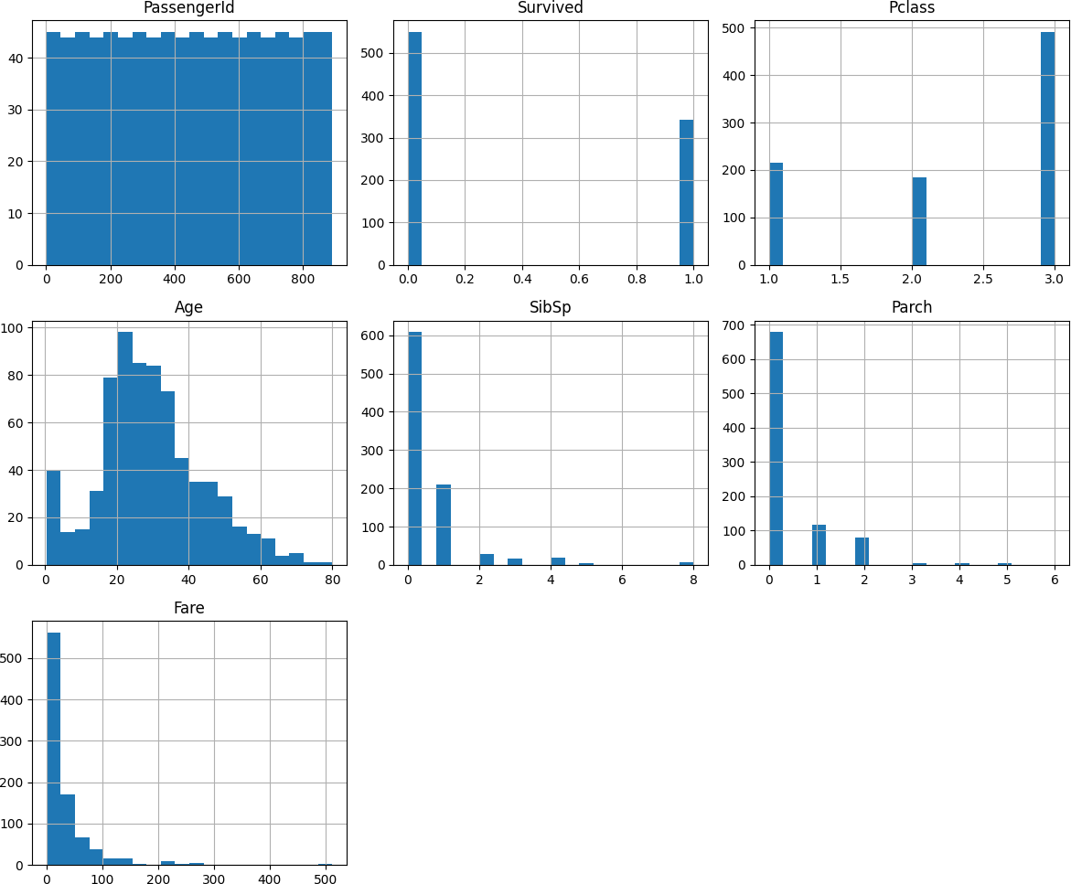
female | 35.0 | 1 | 0 | 113803 | 53.1000 | C123 | S
male | 35.0 | 0 | 0 | 373450 | 8.0500 | 5 | S
... | ... | ... | ... | ... | ... | ... | ...
male | 27.0 | 0 | 0 | 211536 | 13.0000 | 5 | S

Data Cleaning
train.fillna(value=5)
Name Sex Age SibSp Parch
Ticket Fare Cabin Embarked
Mr. Owen
Harris
male 22.0
1
0 A/5 21171 7.2500
5
S
Mrs. John (Florence ggs Th...
en, Miss.
Laina
elle, Mrs. ath (Lily May Peel)
. William Henry
...
vila, Rev. Juozas
 | PassengerId | Survived | Pclass
0 | 1 | 0 | 3 Braund,
1 | 2 | 1 | Cumings,  1 Bradley
 |  |  | Bri
2 | 3 | 1 | 3 Heikkin
3 | 4 | 1 | Futr  1 Jacques He
4 | 5 | 0 | 3 Allen, Mr
... | ... | ... | ...
886 | 887 | 0 | 2 Mont

female | 38.0 | 1 | 0 | PC 17599 | 71.2833 | C85 | C
female | 26.0 | 0 | 0 | STON/O2. 3101282 | 7.9250 | 5 | S

Find Missing values
2 | 3 | 1 | 3
3 | 4 | 1 | 1
4 | 5 | 0 | 3
... | ... | ... | ...
886 | 887 | 0 | 2
887 | 888 | 1 | 1

train['Age'] = train['Age'].fillna(train['Age'].median())
train['Embarked'] = train['Embarked'].fillna(train['Embarked'].mode()[0]) train['Cabin'] = train['Cabin'].fillna('Unknown')
test['Age'] = test['Age'].fillna(test['Age'].median())
test['Fare'] = test['Fare'].fillna(test['Fare'].median()) test['Cabin'] = test['Cabin'].fillna('Unknown')

Remove Duplicates
train.dropna(how="any")

PassengerId Survived Pclass
Name Sex Age SibSp Parch
Ticket Fare Cabin Embarked
0
1
0
3
Braund, Mr. Owen
Harris
male 22.0
1
0 A/5 21171 7.2500 Unknown
S
1
2
1
1
Cumings, Mrs. John Bradley (Florence Briggs
Th...
female 38.0
1
0 PC 17599 71.2833
C85
C
Heikkinen, Miss.
Laina
female
26.0
0
0
STON/O2. 3101282
7.9250 Unknown
S
Futrelle, Mrs.
Henry
Juozas
train = train.drop_duplicates()

Jacques Heath female (Lily May Peel) | 35.0 | 1 | 0 | 113803 | 53.1000 | C123 | S
Allen, Mr. William male | 35.0 | 0 | 0 | 373450 | 8.0500 | Unknown | S
... ... | ... | ... | ... | ... | ... | ... | ...
Montvila, Rev. male | 27.0 | 0 | 0 | 211536 | 13.0000 | Unknown | S
Graham, Miss. female  pd.isna(train) | 19.0 | 0 | 0 | 112053 | 30.0000 | B42 | S

 | PassengerId | Survived | Pclass | Name | Sex | Age | SibSp | Parch | Ticket | Fare | Cabin | Embarked
0 | False | False | False | False | False | False | False | False | False | False | False | False
1 | False | False | False | False | False | False | False | False | False | False | False | False
2 | False | False | False | False | False | False | False | False | False | False | False | False
3 | False | False | False | False | False | False | False | False | False | False | False | False
4 | False | False | False | False | False | False | False | False | False | False | False | False
... | ... | ... | ... | ... | ... | ... | ... | ... | ... | ... | ... | ...
886 | False | False | False | False | False | False | False | False | False | False | False | False
887 | False | False | False | False | False | False | False | False | False | False | False | False
888 | False | False | False | False | False | False | False | False | False | False | False | False
889 | False | False | False | False | False | False | False | False | False | False | False | False
890 | False | False | False | False | False | False | False | False | False | False | False | False

Data Integration (train + test)
891 rows × 12 columns
combined = pd.concat([train, test], axis=0, ignore_index=True) combined.head()

Cumings, Mrs. John
S
0 A/5 21171 7.2500 Unknown
1
male 22.0
Braund, Mr. Owen
3
0.0
1
0
Ticket Fare Cabin Embarked
Name Sex Age SibSp Parch
PassengerId Survived Pclass

Next steps: Generate code with combined | Harris  New interactive sheet
1 2 1.0 1  Data Transformation | Bradley (Florence female Briggs Th... | 38.0 | 1 | 0 | PC 17599 | 71.2833 | C85 | C
1. D2rop Irrelevant3Column1s.0 3 | Heikkinen, Miss. female Laina | 26.0 | 0 | 0 | STON/O2.  3101282 | 7.9250 | Unknown | S
2. Encode Categorical Variables | Futrelle, Mrs.
columns_to_drop = ['PassengerId','Name','Ticket','Cabin']
train = train.drop(columns=[col for col in columns_to_drop if col in train.columns], axis=1) test = test.drop(columns=[col for col in columns_to_drop if col in test.columns], axis=1)
train = pd.get_dummies(train, drop_first=True) test = pd.get_dummies(test, drop_first=True)

Classification Model Building
X = train.drop('Survived', axis=1) y = train['Survived']
from sklearn.model_selection import train_test_split

X_train, X_test, y_train, y_test = train_test_split(X, y,

